**Course Registration Management System**

**Working Flow of Our Website**

There are three sections

* Public
* Student
* Teacher

Its functionalities are given bellow:

**Public site**

All who browse this website, he/she can see these pages.

**Home page**

When we browse to the website, home page appears. Here we can see some information of Khulna University CSE discipline and about our site.

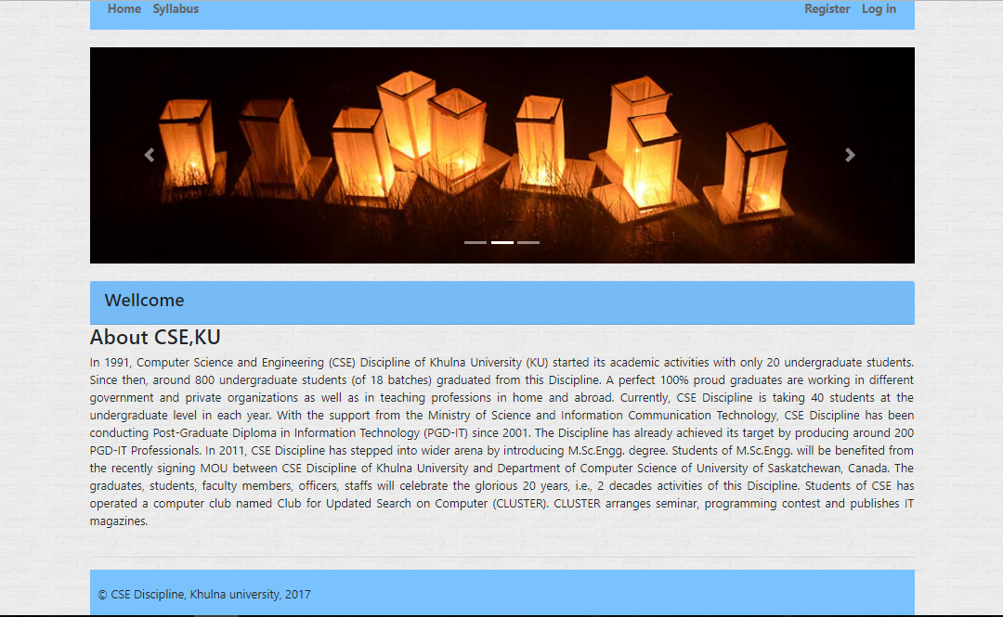

**Syllabus page**

This is the public syllabus page. Here we can search any year-term’s syllabus by selecting the year-term dropdown value. 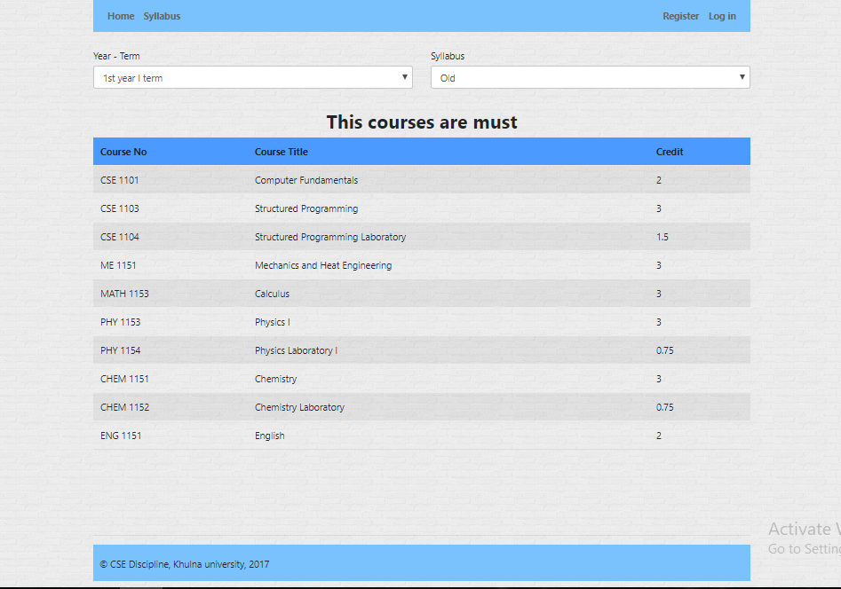

**Login Page**

In this page, we have to provide user name and password to login. If someone is not registered, then he/she have to be registered first.

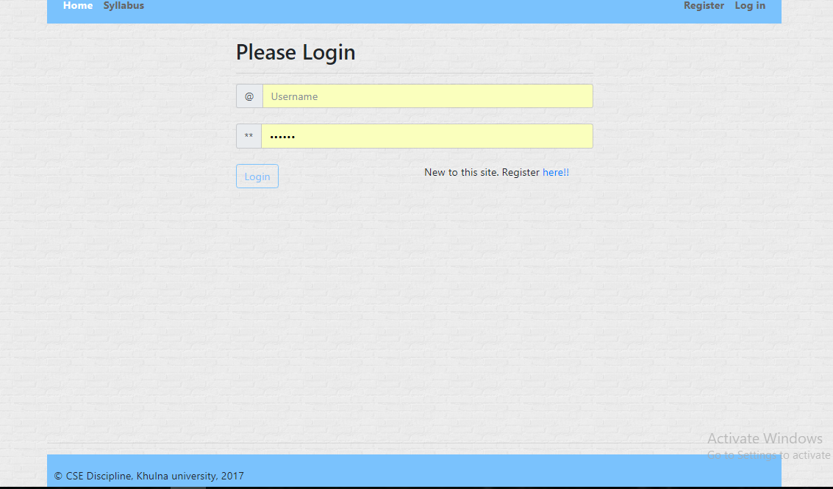

**Registration page**

We have to provide all the information is needed specially required information to register.

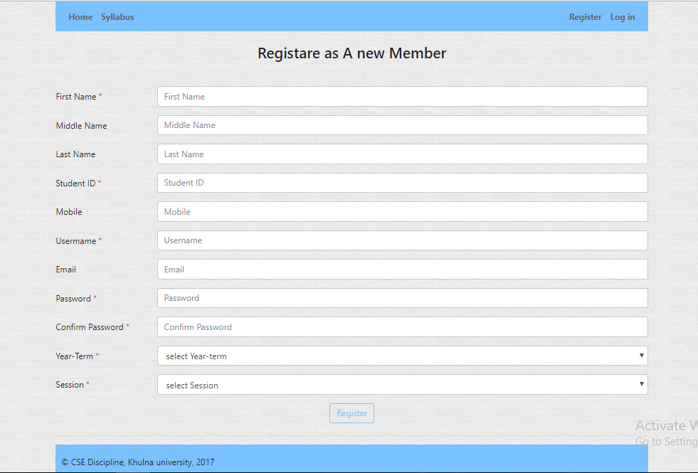

These are the public site of our website. Anyone who are not registered in this site are able to see those pages.

**Student Site**

Here comes the student site. All the students who have an account in this website can see home page which is public home page,personal information, syllabus, registered courses, results, can register courses, can insert results.

**Home page**

This is the same page of public home page except it has different menu bar.



**Syllabus page**

This page is also the same page as the public syllabus page except the menu bar.

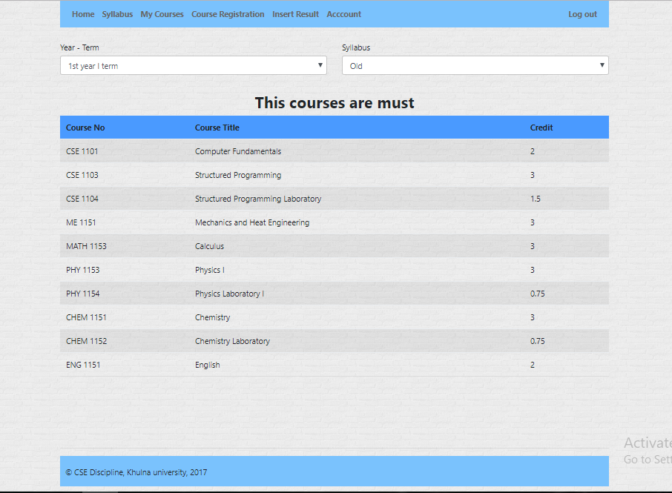

**Account Manage page**

Here a student can see his/her provided information and can update year-term, mobile number, email address and password.

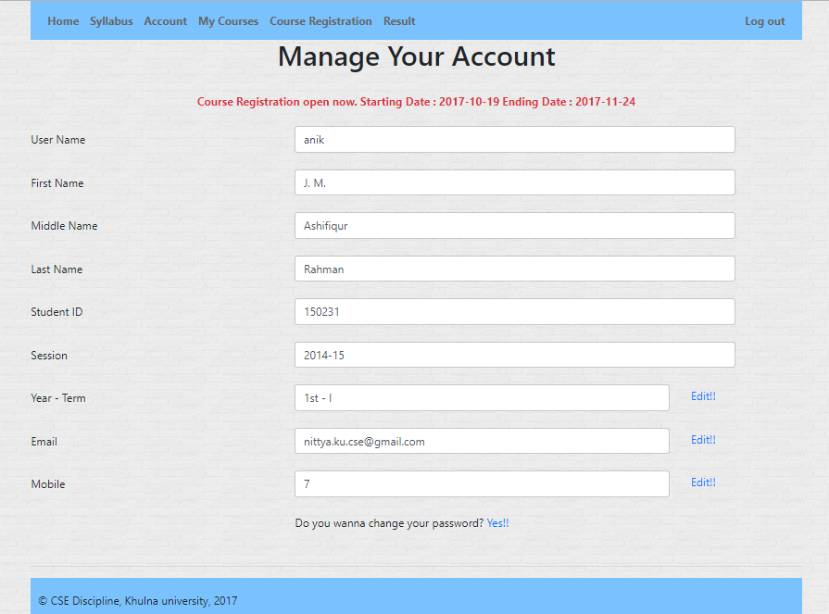

**Change year-term**

When he/she needs to update his/her year-term, just clicks the edit button beside the year-term level. Then a popup appears. 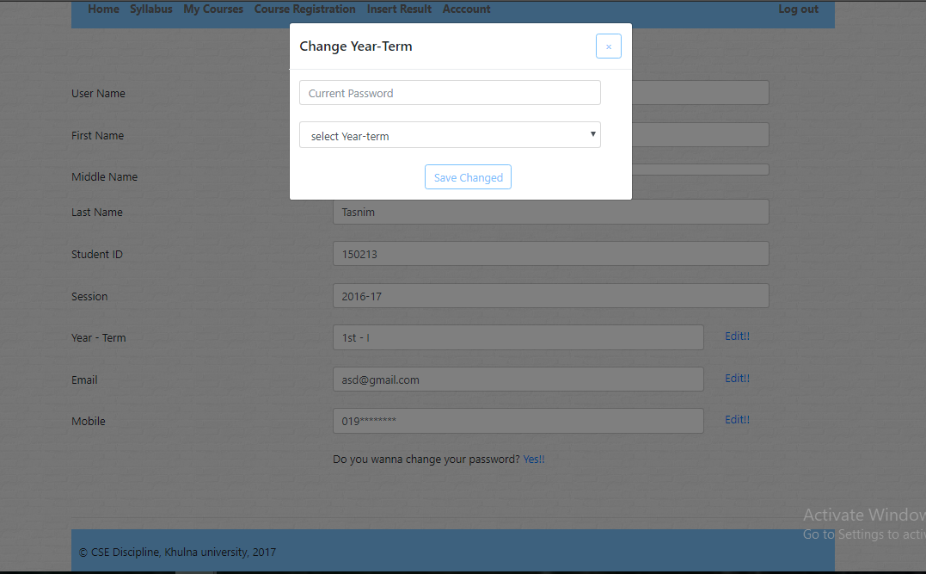

Here we need to provide password and select year-term. Then click the save changes button. If the password is correct, then year-term will be updated. But if something goes wrong it shows an error.

**Change Email Address**

If the student needs to change his current email address, the he needs to click the edit button beside the email address level. Then the popup appears.

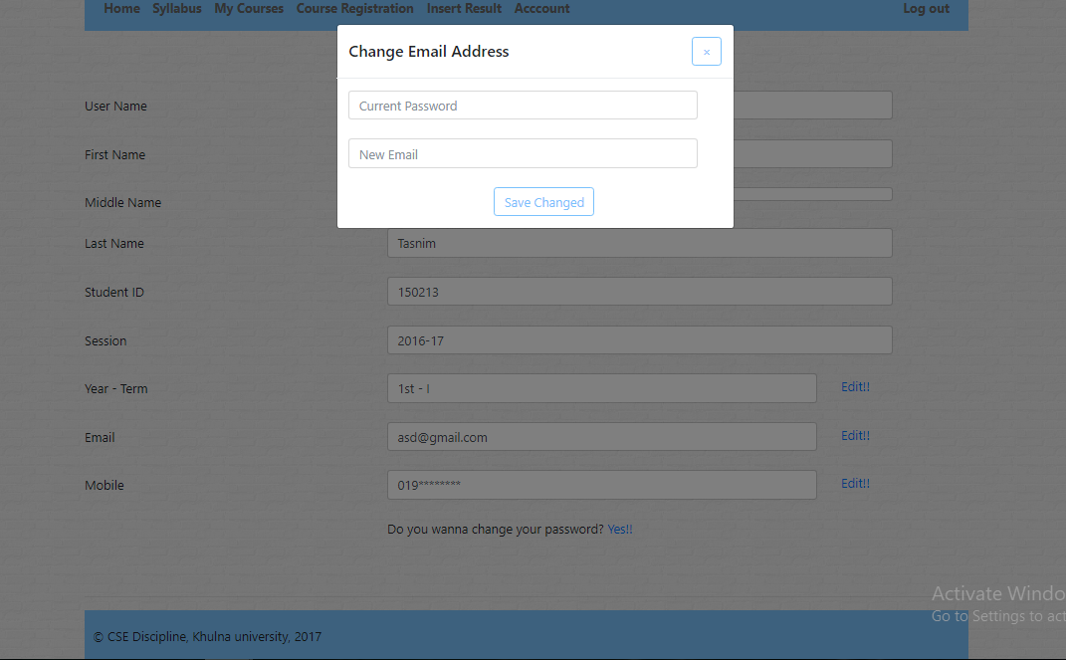

It needs current password and email address. If the current password is not right, then it throws an error. Otherwise the email address will be updated.

**Change Mobile Number**

If someone needs to change his phone number, then he should click the edit button beside the mobile level. Then a popup will appear.

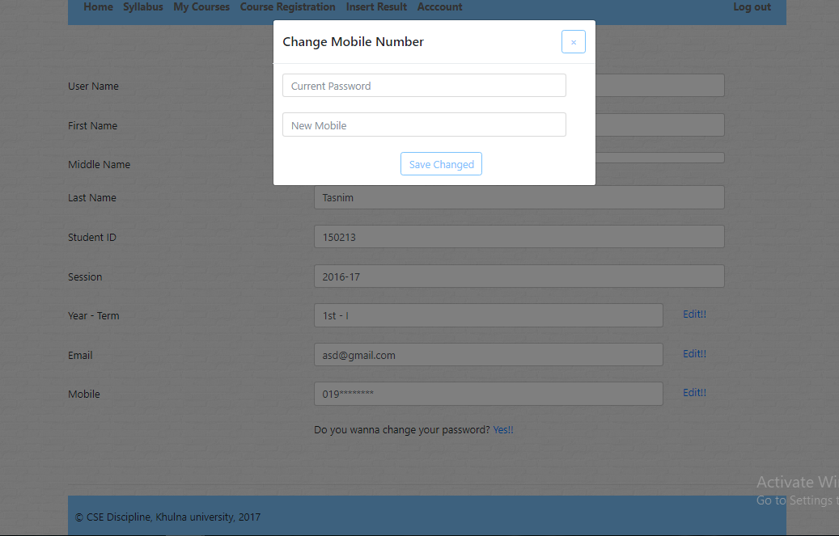

It needs current password and mobile number. If the current password is not right, then it throws an error. Otherwise mobile number will be updated.

**Change Password**

If he/she needs to change his/her password, just click the edit button. Then a popup will be shown.

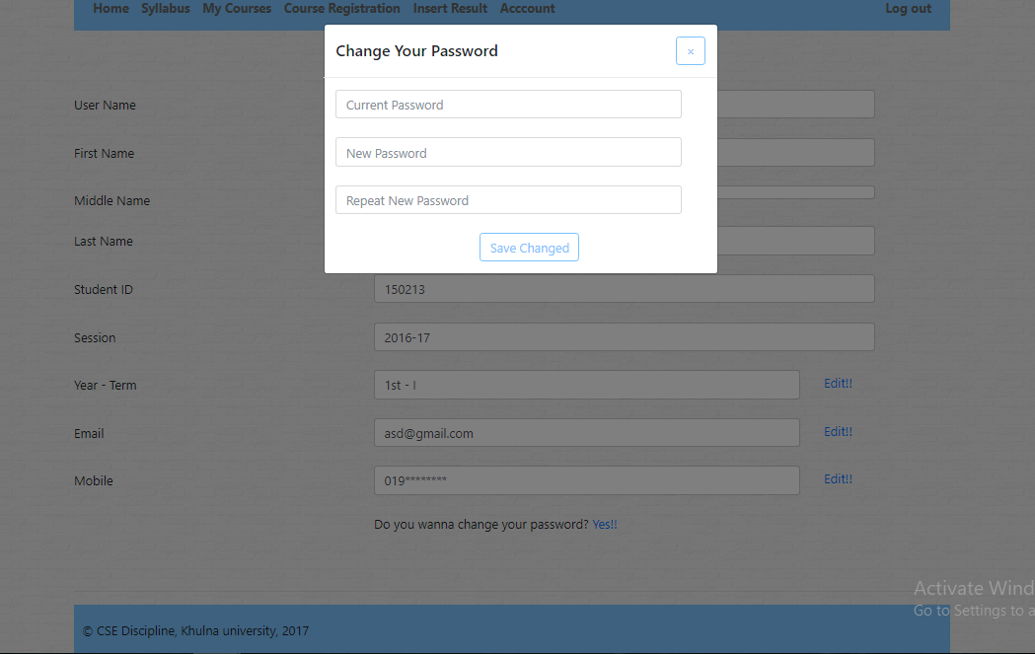

Here we have to give current password a new password twice. If the current password is right and tow new password is matched, then the password will be changed. Otherwise an error will be occurred.

**Course Registration page**

In this page we can registered our courses. First we need to select our year-term and syllabus type. Then input the dropdown field from the selected value. If he has some retake in some courses another table will appear beside the registration table which will display the retake list. After selecting the subjects, he clicks the register button. Then the page redirect to my courses page and course coordinator will receive an request.

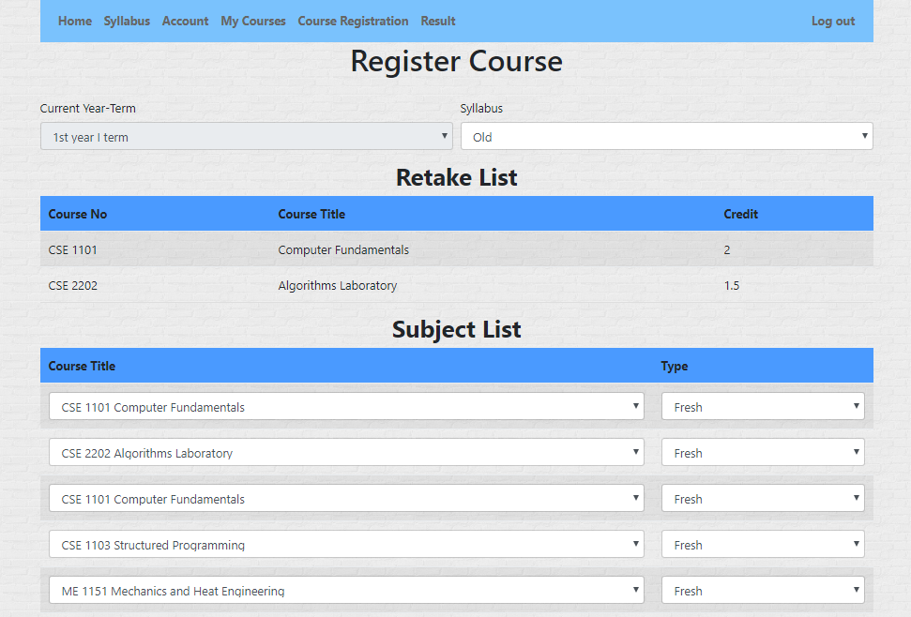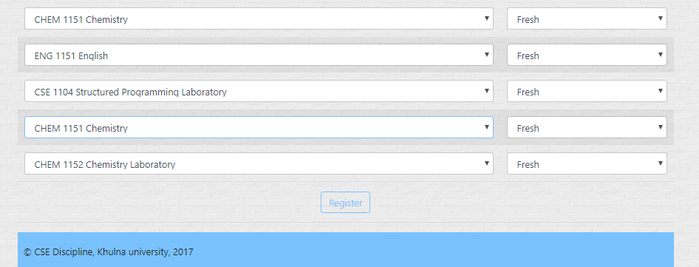

**My courses**

In this page, we can see the courses we have been registered. Which subject is approved and which is not, we can see here. If a subject is not approved, a delete button will appear beside it. We can delete the subject and can register another subject from course registration page.

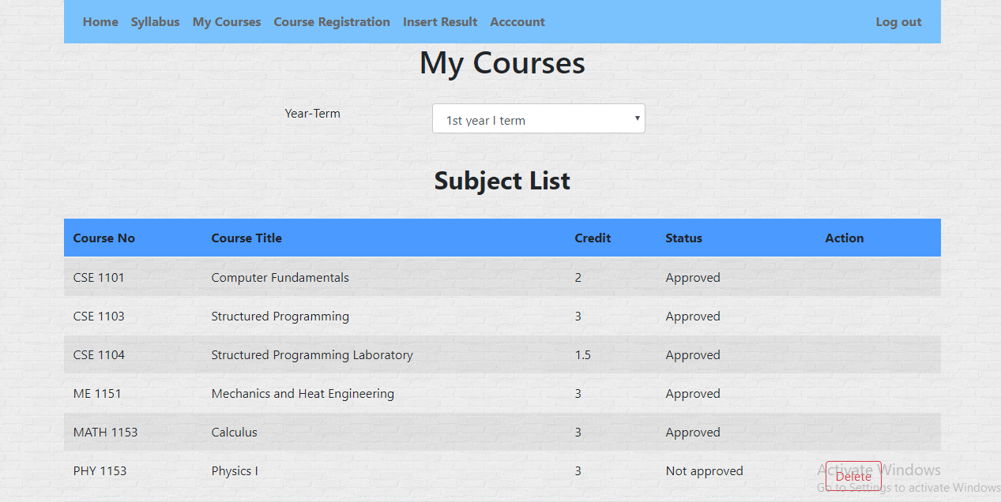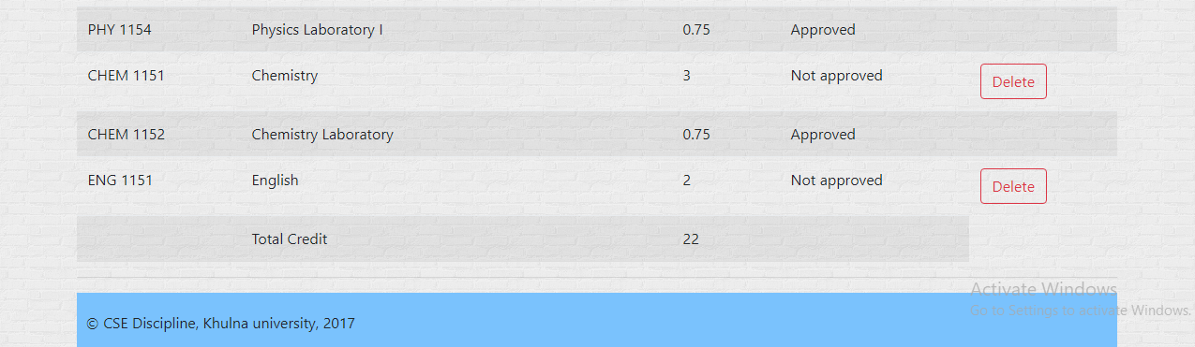

**Insert result page**

He can input the result here. First he has to select year-term and then fill the form.

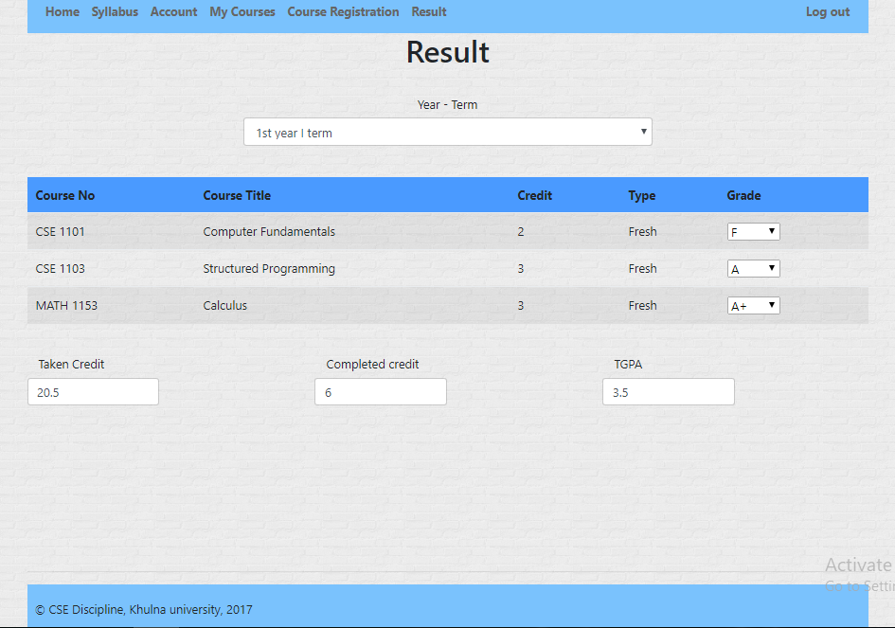

**Teacher site**

In this portion, a teacher can see home page, syllabus, requested student list, can manage his account, student details

.

**Home page**

It is the same public home page except it has teacher’s menu bar.

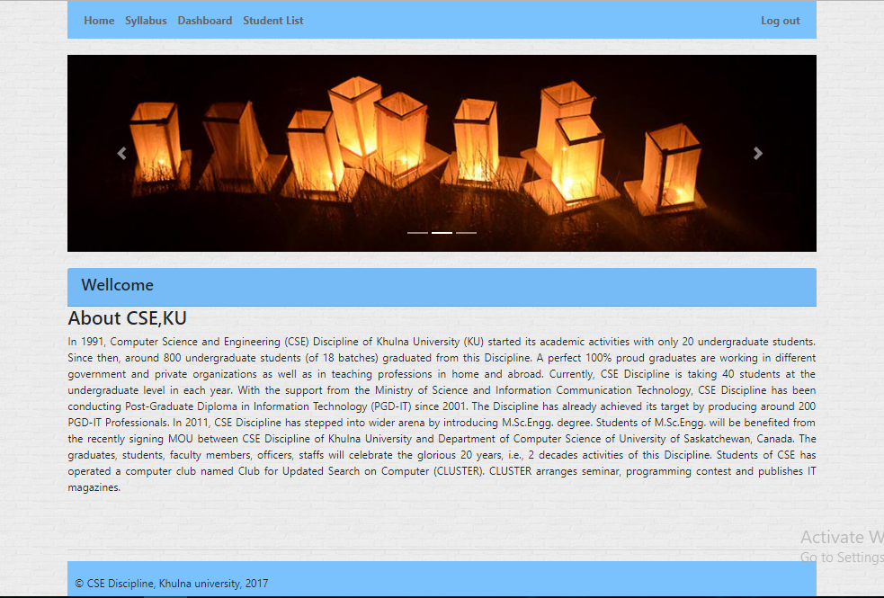

**Syllabus page**

It is also same as the public syllabus page except menu bar. Here we first have to select the year-term and then click the select button.

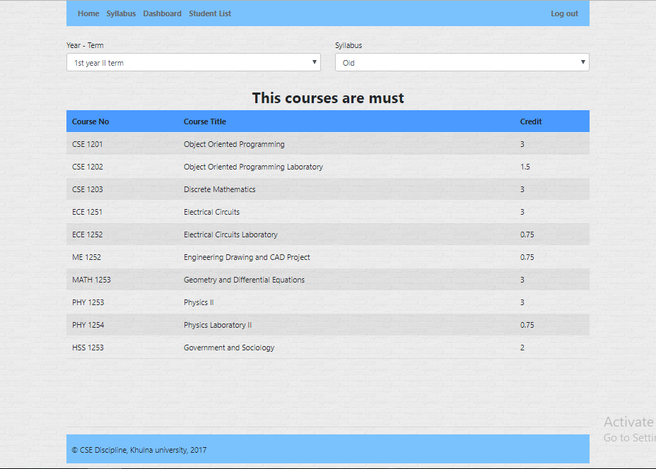

**Dashboard**

Here a teacher can see his user name and can edit his password. He can set the course open or close. And its opening and end date. He can see session and add session here.

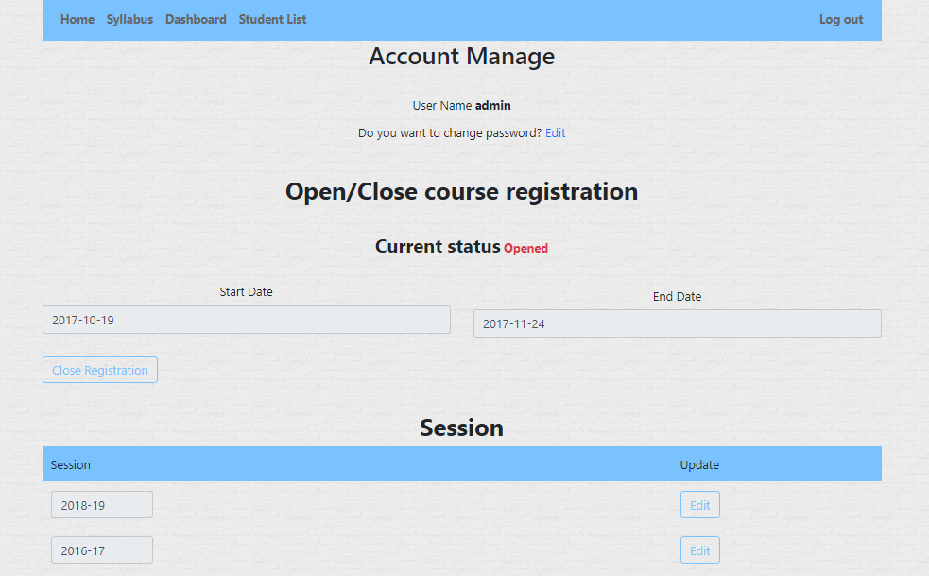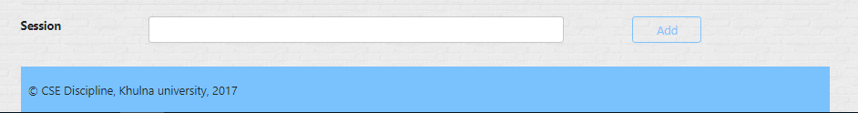

If he click Close Registration button, he can set a new date for course registration open.

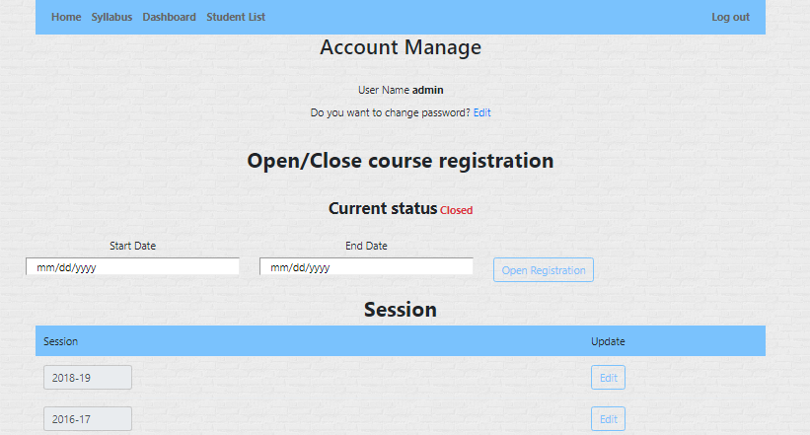

**Password change**

When a teacher needs to change his password, he has to click the edit button. Then a popup will appear.

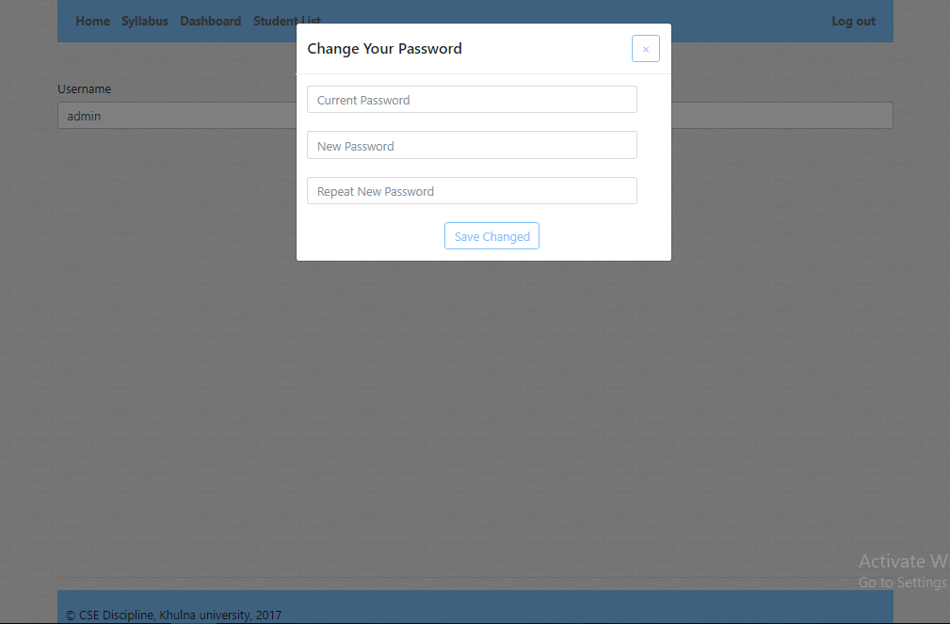

Here he has to give current password and new password twice. If current password is ok and provided new two passwords get matched, then the password will be updated with the new password. Otherwise it is shown an error message.

**Student list page**

In this page, a teacher can search a student by his student id, name, email address, mobile number, year-term, session. Here is a approve button to see students registration details.

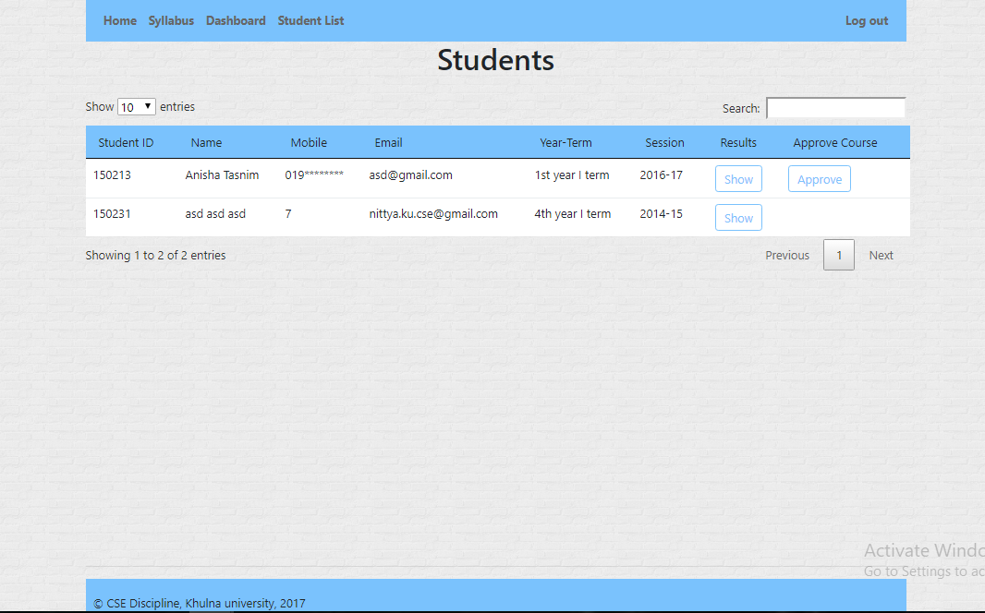

If he click the approve button, then the page redirect to the student registration detail page

**Student Approve page**

Here, teacher can see the student’s registration details. If the student does not eligible for a specific subject, teacher can disapprove the subject.

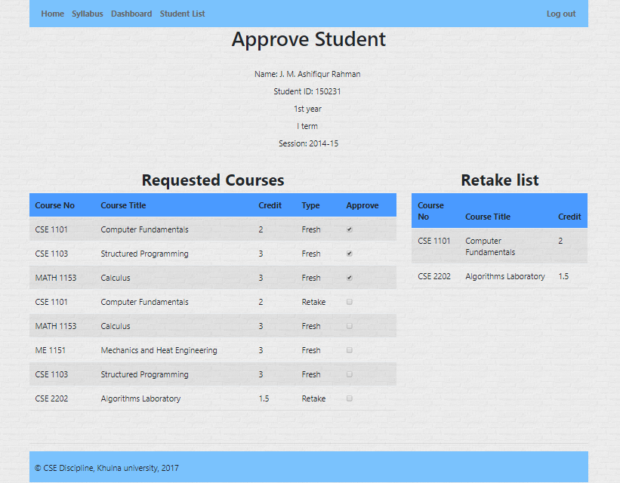

**Student’s Result**:

In student request page, we can see two buttons. One is Approve and another is Show.

If we click show button, we redirect to this page. And we can see his all results. 